Assignment 1

Components:

|  |  |  |  |  |  |  |  |  |
| --- | --- | --- | --- | --- | --- | --- | --- | --- |
| Name | Quantity | Component | |  |  |  |  |  |
| U2 | 1 | Arduino Uno R3 | |  |  |  |  |  |
| Pir1 | 1 | 195.06811254834543 , -128.256475935789 , -52.723706026957416 PIR Sensor | | | | | |  |
| U3 | 1 | Temperature Sensor [TMP36] | | |  |  |  |  |
| Piezo1 | 1 | Piezo |  |  |  |  |  |  |

Circuit Diagram:

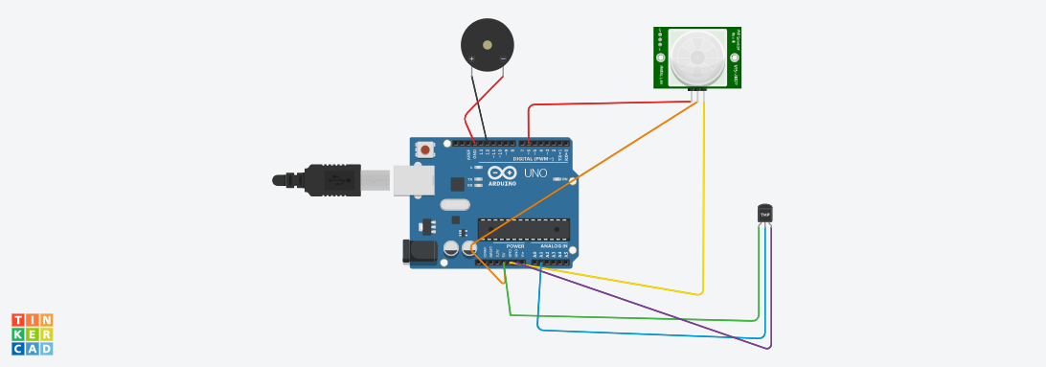

Code:

float temp;

void setup()

{

pinMode(6,INPUT);

pinMode(2,INPUT);

Serial.begin(9600);

}

void loop()

{

if(digitalRead(6)==HIGH)

{

tone(12,523,1000);

Serial.println("unknown detected");

}

else

{

noTone(12);

}

temp=analogRead(A1);

temp=temp*0.48828125;

if(temp>=110.84)

{

tone(12,100,2000);

Serial.print("above 60*C degree temperature\n");

}

else

{

noTone(12);

}

}